**Overview of GHHIN Stocktaking Papers**

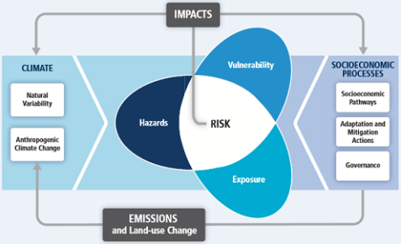Two one-time and complementary technical papers will be prepared during June-July 2017 to inform the common framework of issues and activities that GHHIN will focus on and track through its web-platform and forums; shape the likely content for the global synthesis report; to collect baseline content information; and help expand upon previous guidance documents and identify alignment with the NOAA National Integrated Heat Health Information System.

The reports have been organized around the principles of the IPCC climate Risk Framework. They will take stock of the relevant categories of heat-health knowledge and information which are required to inform decisions and actions across timescales to reduce risks across the dimensions of hazard, vulnerability, exposure, risk reduction, and monitoring impacts.

**Expected Outcomes of Stocktaking Papers**

1. Help organize and inform a common thread framework of domains of information and action to be followed by the GHHIN
2. Provide grounding and content for the development of the global synthesis report, as a one-time effort prior to mechanisms of the platform and forums are established to collect information.
3. Inform core templates for comparative information categories, that can be used as the basis of the country/member profiles.
4. Collect data on existing actions to begin to populate the initial web-based sharing platform and identify key stakeholders, before GHHIN members are asked to contribute.

Stocktaking paper Paper 1: on global heat hazards and human exposure across timescales This report will build on some efforts to compare different systems, and notably update p 28, table 4 of the WHO/WMO Heatwave and Health Guidance on Warning System Development Guidance Document, comparing local and national systems in US, Canada, Germany, Spain, France, UK, China, Hong Kong, Japan, Australia.

Stocktaking paper Paper 2: on human vulnerability to heat and risk reduction actions across timescales This report will notably update Chapter 6 of the WHO/WMO Heatwave and Health Guidance on Warning System Development Guidance Document.

**Paper 1: Stocktaking of Global Heat HAZARD + EXPOSURE**

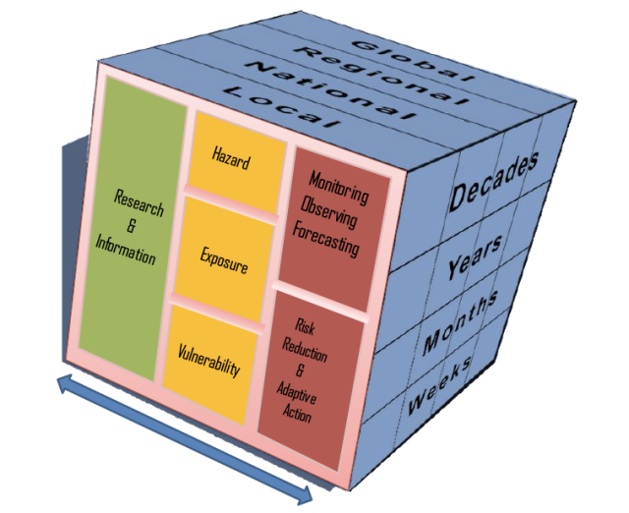**Page target 20-25, with annexes as required**

This stocktaking report will help identify and outline the global state of the science to understand and predict ambient heat related hazards to human health and human population exposure to increasing and extreme temperatures.

It will quickly summarize the literature on the state of the hazard; outline and highlight similarities and differences in systems for characterizing the hazards, and temperature prediction across timescales (weather, S2S, and decadal). It will present key considerations used in the literature for measuring human population exposure to extreme and increasing temperatures.

This stocktaking will inform a common thread framework for GHHIN to track progress being made in key categories, synthesize current science in a standard way, and establish indicators to help structure country profiles that will be completed by GHHIN members autonomously.

**Part 1: Extreme ambient heat hazard characterization**

Describe observed trends of increased warming, of high nighttime temperatures, extreme heat events, of heat hazards in combination with conditions of humidity/air quality.

**Part 2: Research:** what is the research/method used to inform how an extreme heat event is defined? Inclusion of mortality/morbidity/hospital admission data?)

**Part 3: Global, regional, and national observation systems and monitoring systems** of (mortality records capacity, climatological records, RCC capabilities eg: IMD Regional Forecast)

**Part 4: Extreme Heat Prediction**: State of the science in products, sources of predictability, by timescale: climate predictions, climate outlooks, forecasts, warnings); indices

**Part 5: Early Warning Systems.** Diverse priorities across timescales: reference table of comparative heat alert systems; parameters, definitions

**Part 6: Exposure:** Discuss definitions and what makes heat dangerous to humans.

Geographic Determinants: Latitude, Urban Heat Islands; Social Determinants (point to vulnerability chapter).

**Paper 2: Stocktaking of Global Heat VULNERABILITY + RESPONSES:**

**Page target 20-25, with annexes as required**

This stocktaking paper will help identify and outline the global state of understanding human vulnerability to heat exposures, and the broad range of responses and actions which can be taken to reduce human exposures and impacts. It will describe categories of vulnerable populations; highlight similarities and differences in response opportunities and systems, from behavioral to infrastructural, and legal actions which can be taken over different timeframes. Intervention effectiveness will be cited as available. This stocktaking will inform a common thread framework for GHHIN to track progress being made in key categories, synthesize current action and science in a standard way, and establish indicators to help structure country profiles that will be completed by GHHIN members autonomously. It may lead to the creation of indicators of risk and adaptation for extreme heat that can be part of a GIS-based dashboard and GHHIN country profiles.

**Part 1: Population Vulnerabilities**: This section will outline identified diverse population groups whom are vulnerable to exposure to ambient heat conditions, and represent target populations for protection. It should describe geographic, social, temporal and physiological sensitivities. It should highlight target decision makers who have the ability to take protective actions for these high-risk groups (table). E.g. Workers: Business Owners; Psychotropic pharmaceutical patients: Pharmacists/Physicians; Elderly: Families/Social Services.

**Part 2: Responses**

1. **Planning and Governance**: Heat Health Action Plans, legal classification of heat as national emergencies
2. **Institutional Capacity & Partnerships**: Common institutional partners engaged to define and respond to needs. (e.g. who should be/ is involved in forecasting, preparing and responding to the hazard – agreement on lead body)
3. **Engagement and Communication Strategies:** What communication strategies are used and most effective both during an event and for long lead time planning – do communications strategies include targeted outreach to vulnerable populations?
4. **Training and Capacity:** what kinds of training and capacity is needed to better understand and respond to heat health risks
5. **Exposure and vulnerability reducing interventions**
6. Individual
7. Community
8. Work Place
9. Health Facility
10. Policy/Legislative/Regulation
11. Social Services
12. Specified targeted interventions for vulnerable populations

**Part 3: Monitoring and Evaluation** of intervention effectiveness (evaluation products – conference, report), information sufficiency (e.g. vulnerability id, warning accuracy), and feedback mechanisms (ie complaint line, town halls, etc.) .

